Chapter 10, Solution 1.

We first determine the input impedance.

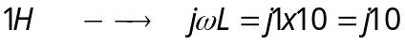
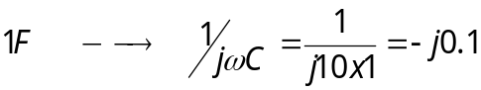

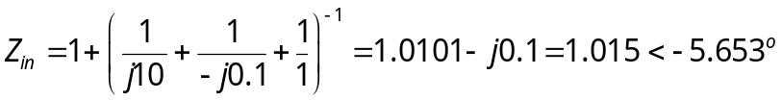

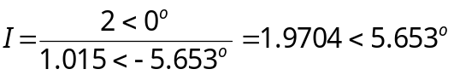

i(t) = 1.9704cos(10t+5.65˚) A

